**Coffee Sales Analysis Report**

**Introduction**

This report presents an analysis of coffee sales data collected between 2019 and 2021. The dataset contains details on customer purchases, product types, roast preferences, and regional distribution. The purpose of the analysis is to uncover sales trends, identify top-performing products, and provide actionable insights that can guide strategic business decisions.

**Objectives**

1. To evaluate overall sales performance across different countries.
2. To identify the most popular coffee types and roast preferences.
3. To examine customer purchasing behavior, including loyalty card usage.
4. To track sales trends over time.

**Data Description**

* Source: Coffee sales dataset with 1,000 transaction records.
* Period Covered: 2019 – 2021.
* Variables: Includes order ID, customer details, product type, roast type, coffee size, price, profit, and country.
* Cleaning: Duplicates and inconsistencies were removed. The dataset was then structured for pivot table analysis and visualization.

**Tools Used: Microsoft Excel**

* Descriptive Statistics to summarize sales
* Vlookup Function
* IFS Function
* Pivot Tables
* Visualization to present findings in the dashboard

**Results**

* The café’s total order and total number of customer’s is 1,000
* The total sales made by the café from 2019 to 2021 is $45,100
* The total profit made by the cafe from 2019 to 2021 is $1,300
* The country that generates the highest revenue is the United States, which generates 79% of the café’s revenue.

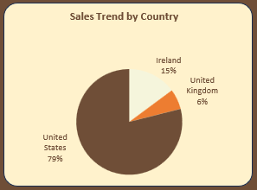

* Top Coffee Types: Arabica, Liberia, and Excelsa emerge as the most purchased coffee types, showing strong consumer preference.

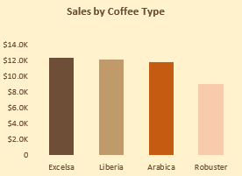

* Sales Trends Over Time: Sales show steady growth, with peaks observed during mid-year and holiday periods, reflecting seasonal demand

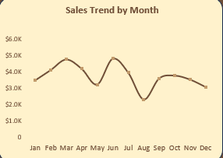

* Roast Preferences: Medium and large roasts are the most popular choices among customers, suggesting a trend toward stronger flavors.

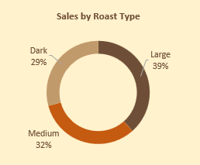

* Customer Segmentation: Customers with loyalty cards contribute significantly to repeat purchases, particularly in the U.S. market.

**Observation**

The dominance of U.S. sales highlights the importance of focusing marketing and distribution strategies in this region. The preference for Arabica and medium roasts indicates that customers lean toward familiar, versatile coffee flavors. Seasonal sales peaks suggest opportunities for targeted promotions during holidays and mid-year events.

**Recommendations**

* Focus marketing and distribution efforts on the U.S. market.
* Expand product lines for Arabica and medium roasts.
* Strengthen loyalty programs internationally to boost retention.
* Launch seasonal campaigns during mid-year and festive periods.

**Conclusion**

The business has a strong foundation in the U.S. market with clear product preferences. Targeted promotions and expanded offerings can further drive growth and customer loyalty.